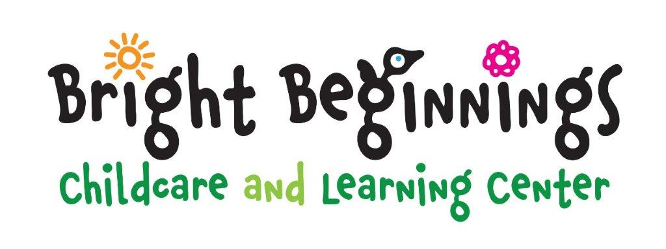

**Infant Program**

Five Days $315

Four Days $300

Three Days $270

Two Days $210

Daily $135

**Toddler Program**

Five Days $290

Four Days $275

Three Days $255

Two Days $204

Daily $125

**Younger Preschool Program**

Five Days $280

Four Days $270

Three Days $245

Two Days $204

Daily $120

**Older Preschool Program**

Five Days $275

Four Days $265

Three Days $240

Two Days $197

Daily $120

**Tuition Schedule**

**Chisago City Location**

**\*\*Effective: January 1, 2024\*\***

* There is a $75 registration fee per family due when registration is completed. $125 registration fee to hold an infant spot.
* **A 10% discount is given to the lower priced programs for families enrolling two or more children**
* Fees are due the 1st day of attendance each week.  A late payment of $40.00 will be charged for each week past due
* Breakfast, lunch and snack are included in the tuition unless otherwise indicated.
* Children picked up after normal closing time are subject a late fee of $25 for the 1st 15 minutes, then $15 every 15 minutes thereafter.
* No credits will be given when a child is sick or not attending their regular scheduled time.  This includes holidays and vacations.
* A two (2) week written withdrawal notice is required after the child has begun attending our facility.
* Return checks will be subject to a $40.00 surcharge.